***Seven Themes of Geography: The Great Barrier Reef***

*Geographers use seven concepts to help investigate and understand the world. As you learn to use each of these key ideas you will begin to think like a geographer. The seven key concepts in Geography are:*

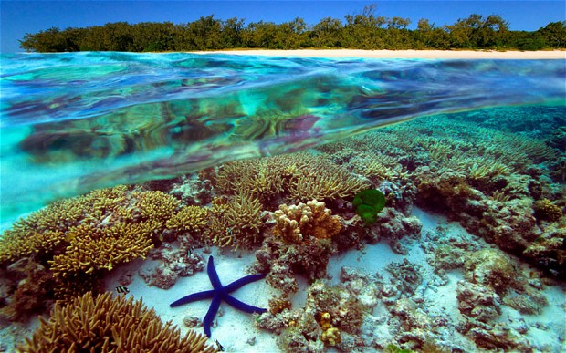***S:*** *Space*

***P:*** *Place*

***I:*** *Interconnection*

***C:***  *Change*

***E:*** *Environment*

***S:*** *Sustainability*

***S:*** *Scale*

*A way to remember these seven concepts is to think of the acronym* ***SPICESS***

***Space***

1. **Location**: Where is the Great Barrier reef located? (*Use directional words, (e.g. North, South, East, West)*

|  |
| --- |
|  |
|  |

1. **Spatial Distribution**: As the largest living structure on the planet, what is the **size** of the Great Barrier Reef?

|  |
| --- |
|  |
|  |

***Place: Physical Characteristics that define a place***

1. ***Landforms***

|  |
| --- |
|  |

1. ***Climate:***

|  |
| --- |
|  |

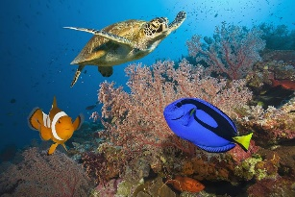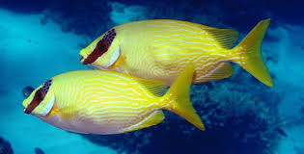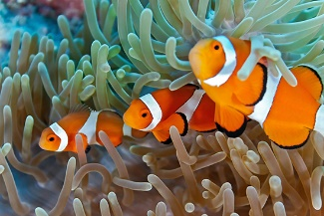

1. ***List 3 other physical characteristics of the Great Barrier Reef.***

|  |
| --- |
|  |
|  |

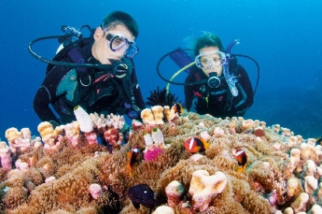

***Interconnection***

1. ***Describe how people interact with the nature of the Great Barrier reef.***

|  |
| --- |
|  |
|  |

***Change***

1. ***Identify the major environmental changes to Great Barrier reef?***

|  |
| --- |
|  |
|  |

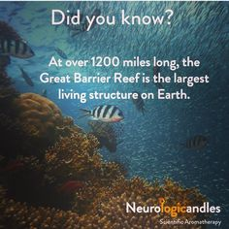

***Environment***

1. ***Is the Great Barrier Reef a natural environment or a human environment?***

|  |
| --- |
|  |
|  |

1. ***List the resources that this environment provides for people?***

|  |
| --- |
|  |
|  |

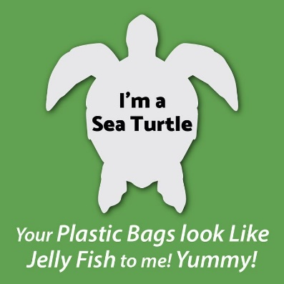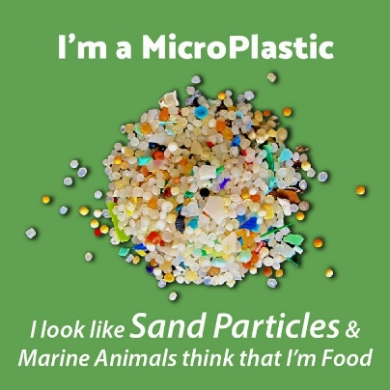

***Sustainability:***

1. ***Provide some examples of sustainability solutions to preserve the Great Barrier reef.***

|  |
| --- |
|  |
|  |
|  |
|  |

***Scale:*** *The concept of scale is about the way that geographical issues or problems can be examined at different spatial levels – local, regional, national, international or global.*

1. ***Identify the scale (local, National or Global) of each of the following issues impacting the Great Barrier Reef.***
2. *Coral bleaching—caused by elevated sea temperatures due to climate change:*

***(local, National or Global)***

***Reason:***

|  |
| --- |
|  |
|  |

1. *Overfishing in the reef:* ***(local, National or Global)***

***Reason:***

|  |
| --- |
|  |
|  |

1. *Pollution from land-based run-off, leading to impacts like outbreaks of crown-of-thorns starfish.*  ***(local, National or Global)***

***Reason:***

|  |
| --- |
|  |
|  |

